UAT Plan

for

[Kaia Special needs Biomedical solution]

Index

1. Scope 3

1.1. Objectives and business requirements 3

1.2. Scope 3

2. Testing team 4

3. Environmental requirements 5

3.1. Hardware requirements 5

3.2. Software requirements 5

4. Test Scripts 1

# Scope

## Objectives and business requirements

The goal and scope of this User Acceptance Test is to test the functionality/ applicability of the current model of Kaia special need biomedical glasses to suit her needs.

## Scope

Kaia’s a blind person who requires help navigating without the use of a cane, luckily they are still lightsensitive.  
  
Other requirements are:

* Easy to learn,
* finding friends,
* Minimal use of cane/braile

Though on paper the current model of kaia special needs biomedical solution works for kaia, this UAT will test its compatability in real life environments, and whether or not the calibrations are functional.

## System Diagrams

In this section, paste any drawings or diagrams that help the UAT team understand the program being tested. With each drawing include a brief explanation of how the drawing represents the application or system being tested.

*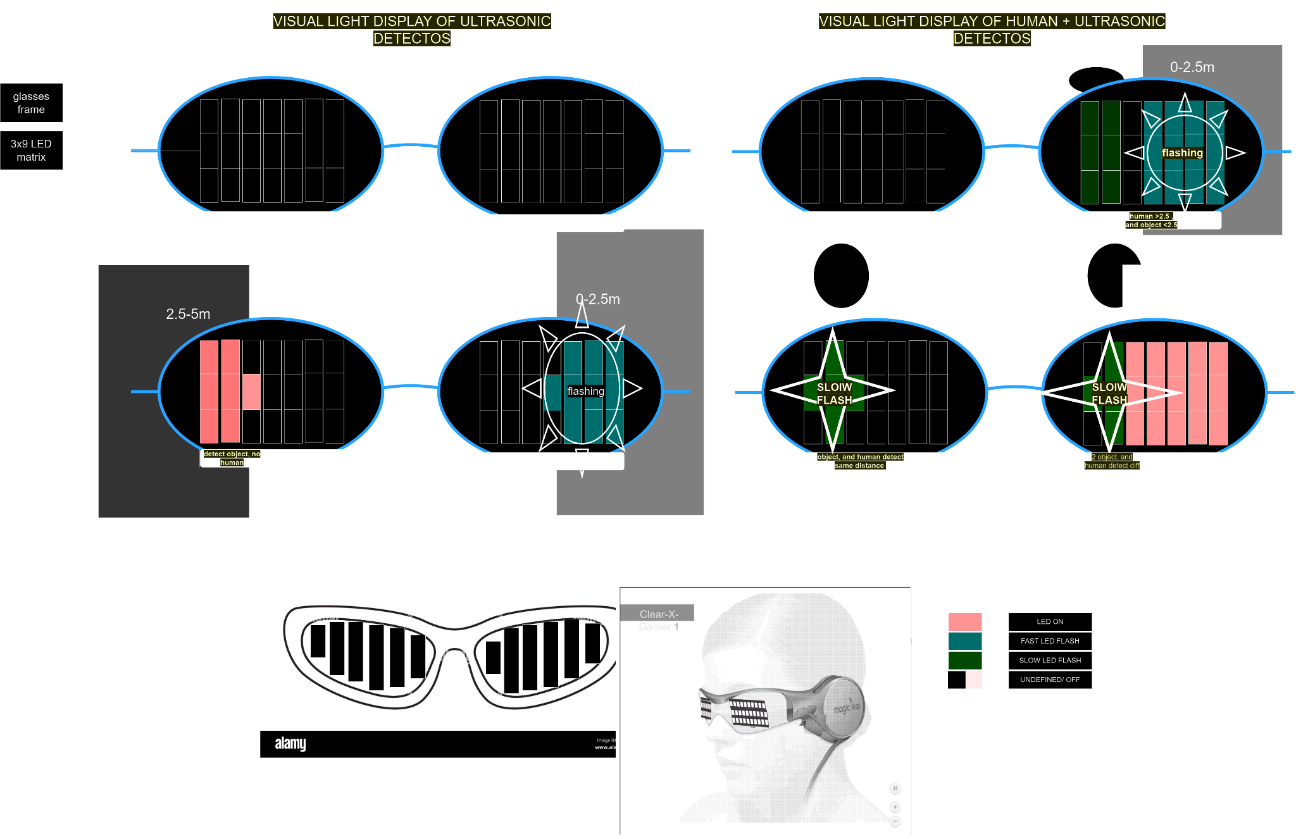  
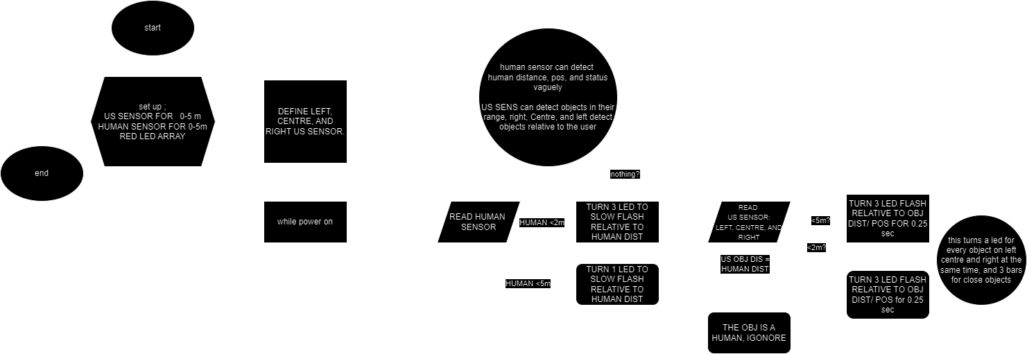  
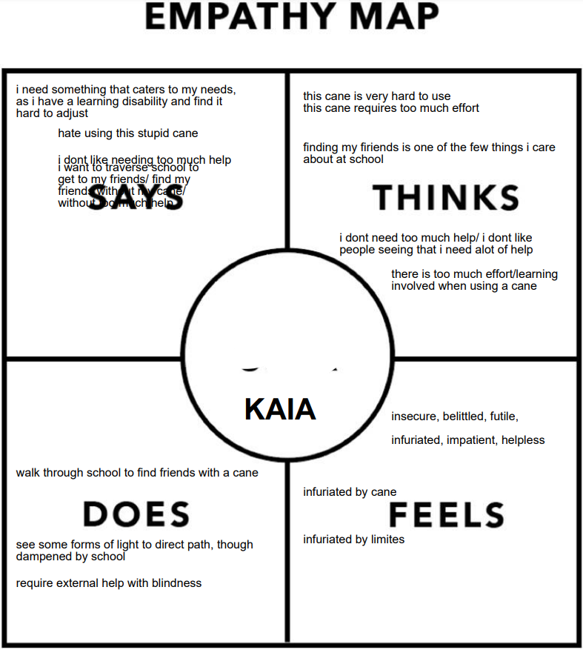*

# Testing team

In this section, list out members of your QA team and what their roles will be during UAT.

Example:

| **Name** | **Responsibilities** |
| --- | --- |
| Elliott | UAT Coordinator - handles communication between end users and QA team UAT conductor - conduct and completes UAT tests and functions with testers and UAT “recipiant” |
| Kaia | Special needs UAT “recipiant” |
| Alex liu | UAT tester - does the tests listed in the UAT under test conditions to complete testing critera |
| Aarav | UAT tester |

# Environmental requirements

## Hardware requirements

* Kaia biomedical prototype
  + Glasses frame
  + 1x9 LED BAR displays
  + US SENSOR
  + SMART HUMAN SENSOR
  + RASBERY PI COMPUTER

RASBERY PI COMPUTER:

* Quad core Cortex-A72 64-bit 1.8GHz.
* 8GB SDRAM
* 5.0 GHz IEEE 802.11ac wireless, Bluetooth 5.0, BLE.
* 2 USB 3.0 ports; 2 USB 2.0 ports.

## Software requirements

* SMART HUMAN SENSOR LIBRARIES
* RASBERY PI OPERATING SYSTEMS

# Test Scripts

This section is more important than it seems—it is crucial that both the QA team and the testers know what features must be tested, especially if you’re testing a lot at once.

| **Test** | **Describe the feature being tested** | **Describe the user input or test data** | **Describe the pass criteria** |  |
| --- | --- | --- | --- | --- |
| 1.1 | Wall detection / identification | 1. User wears vision but not light restricting blindfold 2. User walks near wall | 1. User see’s LED light up 2. LED’s are relative to wall position 3. LED’s change to flash when 0-2.5 | Tester name:   |  | PASS | | --- | --- | |  | FAIL |   Observations: |
| 1.2 | Human detection / identification | 1. User wears vision but not light restricting blindfold  2. User walks near human | 1. User see’s LED’s slow flash 2. LED’s are relative to human pos | Tester name:   |  | PASS | | --- | --- | |  | FAIL |   Observations: |
| 1.3 | Wall and human detection/ identification | 1. User wears vision but not light restricting blind fold 2. User walks towards wall with human behind it | 1. LED’s turn on for Wall within 0-5m 2. LED’s turn to flash for wall within 0-2.5m 3. LED’s turn to slow flash for human 0-5m 4. LED’s are relative to position | Tester name:   |  | PASS | | --- | --- | |  | FAIL |   Observations: |

Write step-by-step, detailed but concise instructions on how to test the feature.